EPIC 05
INTER-SERVICE COMMUNICATION & RESILIENCE
JIRA TASK 03
Circuit Breaker & Fallback
Final Technical Documentation

Field | Value
Project | microservices-architecture-fundamentals
Epic | EPIC 05 — Inter-Service Communication & Resilience
JIRA Task | Task 03 — Circuit Breaker & Fallback
Date | 23 September 2026
Effort | 8 Hours
Priority | Critical
Primary Services | Order Service + User Service
Order Service (DEV) | http://localhost:8082
User Service (DEV) | http://localhost:8090
Order Database | order_service_db
Author | Abhishek Gande

1. Document Purpose
This document records the implementation, configuration, testing, runtime evidence and operational verification completed for JIRA Task 03 — Circuit Breaker & Fallback under EPIC 05. The task builds on the REST communication, timeout and retry work from the preceding task and adds a Circuit Breaker around the Order Service call to User Service.
The evidence section incorporates the supplied Postman and Spring Boot Actuator screenshots. The screenshots are treated as runtime evidence from the development environment and are not presented as production measurements.

2. Task Objective and Scope
Objective: Understand and implement the Circuit Breaker pattern to prevent cascading failures between microservices.
The task requirements covered:
- Understand the CLOSED, OPEN and HALF_OPEN states.
- Protect the Order Service → User Service call with a Circuit Breaker.
- Configure failure threshold, sliding window, open-state wait duration and half-open permitted calls.
- Provide a fallback response when User Service is unavailable.
- Test healthy operation, repeated downstream failure, circuit opening and recovery.
- Record logs and runtime state-transition evidence.
- Document the Circuit Breaker state model and test results.
Circuit Breaker/fallback scope is intentionally limited to Task 03. The implementation does not introduce a separate event-driven fallback workflow or business-data cache.

3. Development Environment
Component | Development Value
Order Service profile | dev
Order Service port | 8082
Order database | order_service_db
User Service port | 8090
User lookup endpoint | GET /api/users/{id}
Order creation endpoint | POST /api/v1/orders
Database | MySQL
Build | Maven
Runtime observability | Spring Boot Actuator
Circuit Breaker library | Resilience4j
HTTP client | RestTemplate

The development profile is used for the local validation performed in this task. The existing order_service_db database is retained; no replacement development database is introduced.

4. Architecture and Request Flow
The implemented request path remains intentionally simple: the controller delegates order creation to the service layer, which validates the referenced user through UserServiceClient before persisting the order. UserServiceClient applies the existing retry policy and is protected by the Resilience4j Circuit Breaker.
Postman
|
v
Order Service :8082
|
v
OrderService
|
v
UserServiceClient
|
+--> Circuit Breaker: userService
| |
| +--> CLOSED: invoke protected method
| +--> OPEN: reject call immediately
| +--> HALF_OPEN: permit limited test calls
|
v
RestTemplate
|
v
User Service :8090
|
v
GET /api/users/{id}
The Order Service does not access the User Service database directly. User information is obtained through the User Service API.

5. Circuit Breaker State Model
State | Meaning in this implementation | Observed evidence
CLOSED | Normal requests are allowed. Failures are recorded against the configured sliding window. | Healthy order creation returned 201 Created.
OPEN | Calls are rejected by the Circuit Breaker instead of reaching the unavailable User Service. | Order Service logs showed CallNotPermittedException and fallback; Actuator events recorded failure-rate exceeded.
HALF_OPEN | After the configured open-state wait, limited test calls are allowed to determine whether the dependency has recovered. | Actuator snapshot showed HALF_OPEN and events recorded OPEN → HALF_OPEN.

CLOSED
|
| failure rate reaches configured threshold
v
OPEN
|
| wait-duration-in-open-state = 10s
v
HALF_OPEN
|
| successful permitted call
v
CLOSED

6. Circuit Breaker Configuration
The development configuration used for the task is:
resilience4j:
circuitbreaker:
instances:
userService:
failure-rate-threshold: 50
minimum-number-of-calls: 5
sliding-window-size: 10
wait-duration-in-open-state: 10s
permitted-number-of-calls-in-half-open-state: 3
automatic-transition-from-open-to-half-open-enabled: true
ignore-exceptions:
- order_service.exception.UserNotFoundException
Property | Configured value | Purpose
failure-rate-threshold | 50% | Opens the circuit when the failure rate reaches the configured threshold after the minimum call requirement is satisfied.
minimum-number-of-calls | 5 | Prevents the failure-rate calculation from opening the circuit on an insufficient sample.
sliding-window-size | 10 | Defines the number of recent calls considered by the count-based window.
wait-duration-in-open-state | 10s | Keeps the circuit open before recovery testing.
permitted-number-of-calls-in-half-open-state | 3 | Limits recovery test traffic while HALF_OPEN.
automatic-transition-from-open-to-half-open-enabled | true | Allows automatic transition to HALF_OPEN after the wait period.
ignore-exceptions | UserNotFoundException | Prevents a normal missing-user business error from being counted as dependency failure.

7. Interaction with Retry Handling
The implementation retains the retry logic from Task 02 inside UserServiceClient. A transient connection/read failure is retried up to three attempts with exponential backoff beginning at 500 ms (500 ms, then 1000 ms before the next attempt). After the final failed attempt, UserServiceUnavailableException is raised and the Circuit Breaker records the protected method failure.
When the Circuit Breaker is OPEN, Resilience4j rejects the call before the protected method executes. Therefore the retry loop is not repeatedly executed while the circuit is already open. This is important because it prevents an open circuit from continuing to generate downstream traffic.

8. Fallback and Failure Handling
@CircuitBreaker(name = "userService", fallbackMethod = "getUserFallback")
public UserResponse getUserById(Long userId) {
...
}
public UserResponse getUserFallback(Long userId, Throwable t) {
...
throw new UserServiceUnavailableException(
"User Service is currently unavailable (circuit breaker open)"
);
}
The fallback preserves UserNotFoundException rather than masking a genuine 404 as a service outage. Other downstream failures are translated to UserServiceUnavailableException, which the global exception handler exposes to the API client as HTTP 503 Service Unavailable.

9. Test Scenarios and Results
Scenario | Request / Action | Observed result | Status
Healthy dependency | POST /api/v1/orders with userId 1 while User Service is running. | 201 Created; order persisted. | PASS
User Service unavailable | Stop User Service and create an order. | Retry attempts occurred; final controlled 503 response. | PASS
Repeated dependency failure | Repeat calls while User Service remains stopped. | Circuit Breaker reached failure threshold; failure-rate-exceeded event recorded. | PASS
Circuit OPEN | Call Order Service after circuit opens. | CallNotPermittedException observed; fallback/503 returned. | PASS
Recovery | Restart User Service and wait for open-state duration. | Recovery test call succeeded; order creation returned 201. | PASS
Missing user | POST order with userId 999999. | 404 User Not Found; UserNotFoundException recorded as IGNORED_ERROR by Actuator. | PASS
Actuator health | GET /actuator/health. | HTTP 200; application health reported UP. | PASS
Circuit Breaker Actuator | GET /actuator/circuitbreakers. | userService instance exposed with runtime state and call metrics. | PASS
Circuit Breaker events | GET /actuator/circuitbreakerevents. | Failure, threshold, OPEN → HALF_OPEN and ignored-error events visible. | PASS

10. Runtime Evidence — Postman and Actuator
The following screenshots were supplied from the actual development test session. They are included as primary runtime evidence for the corresponding verification points.
Final evidence set — ordered by the verification flow: healthy request → dependency outage → business 404 → Actuator health/state/events → recovery.
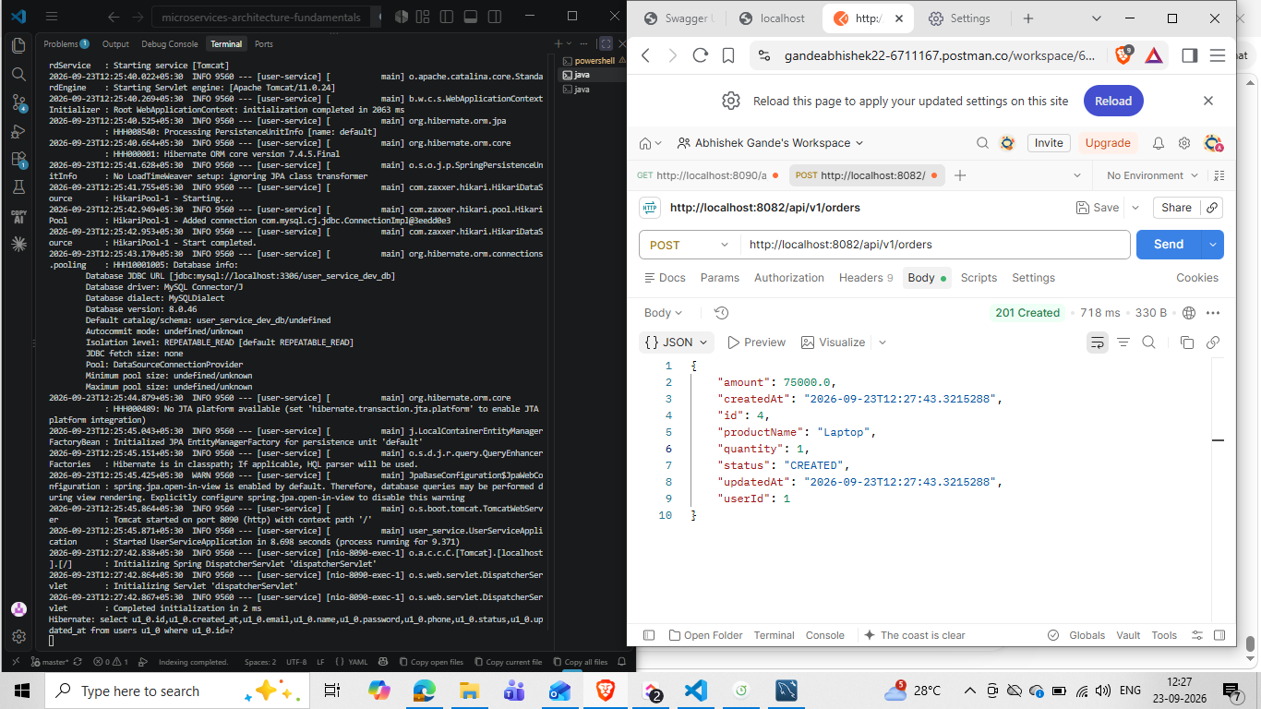
Figure 1 — Postman healthy-path verification: POST /api/v1/orders with userId 1 returned HTTP 201 Created and a persisted order response.
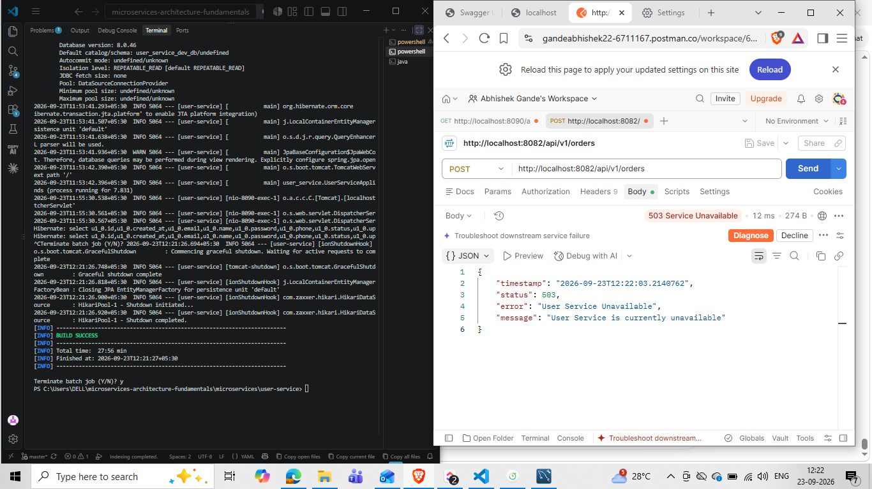
Figure 2 — Postman dependency-failure verification: with User Service stopped, POST /api/v1/orders returned HTTP 503 Service Unavailable with the controlled downstream-failure message.
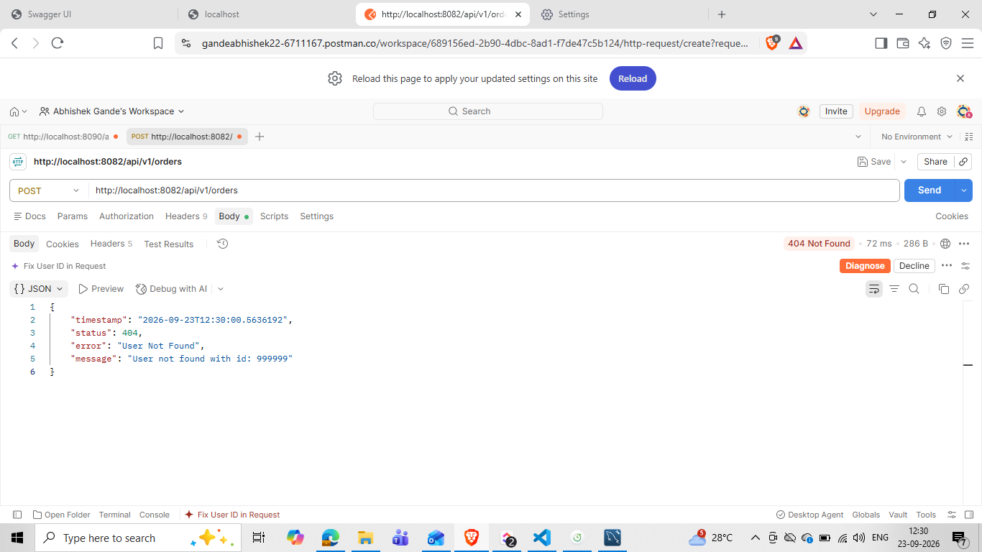
Figure 3 — Postman business-error verification: POST /api/v1/orders with userId 999999 returned HTTP 404 User Not Found; this is a non-retryable business outcome.
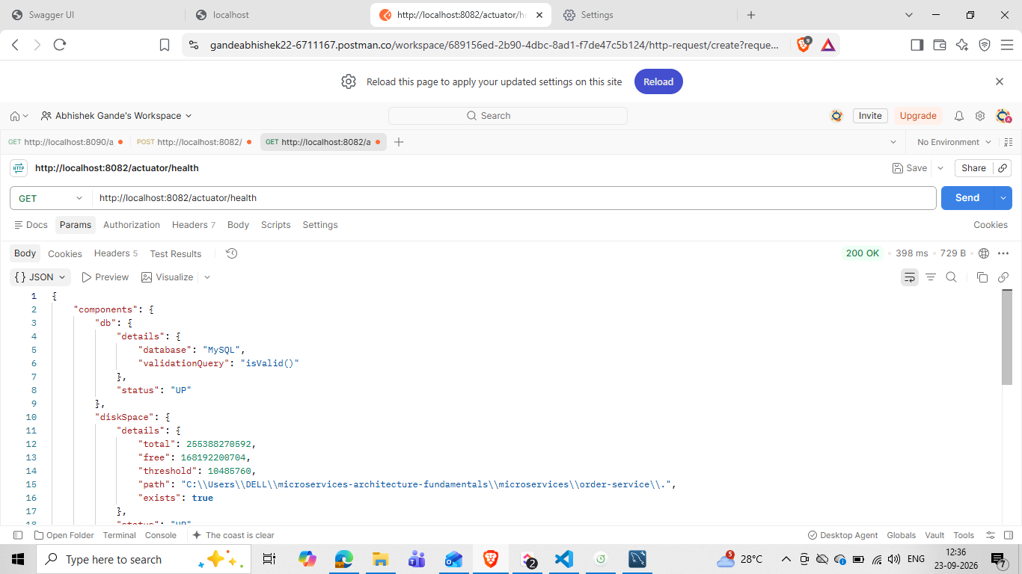
Figure 4 — Actuator health verification: GET /actuator/health returned HTTP 200 OK and reported the database, disk-space, liveness and readiness indicators as UP.
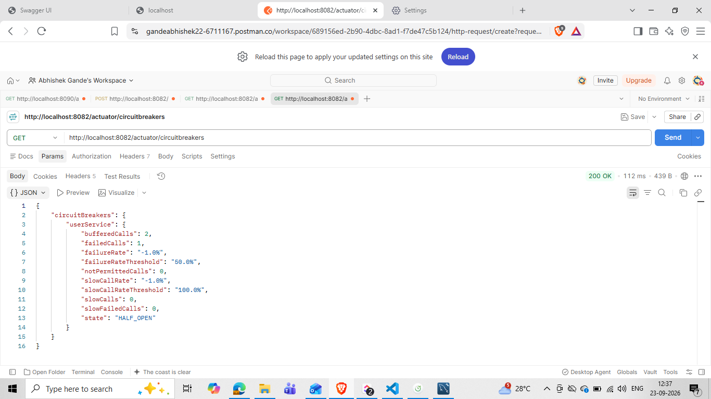
Figure 5 — Circuit Breaker Actuator snapshot: GET /actuator/circuitbreakers exposed the userService instance and captured its runtime state as HALF_OPEN.
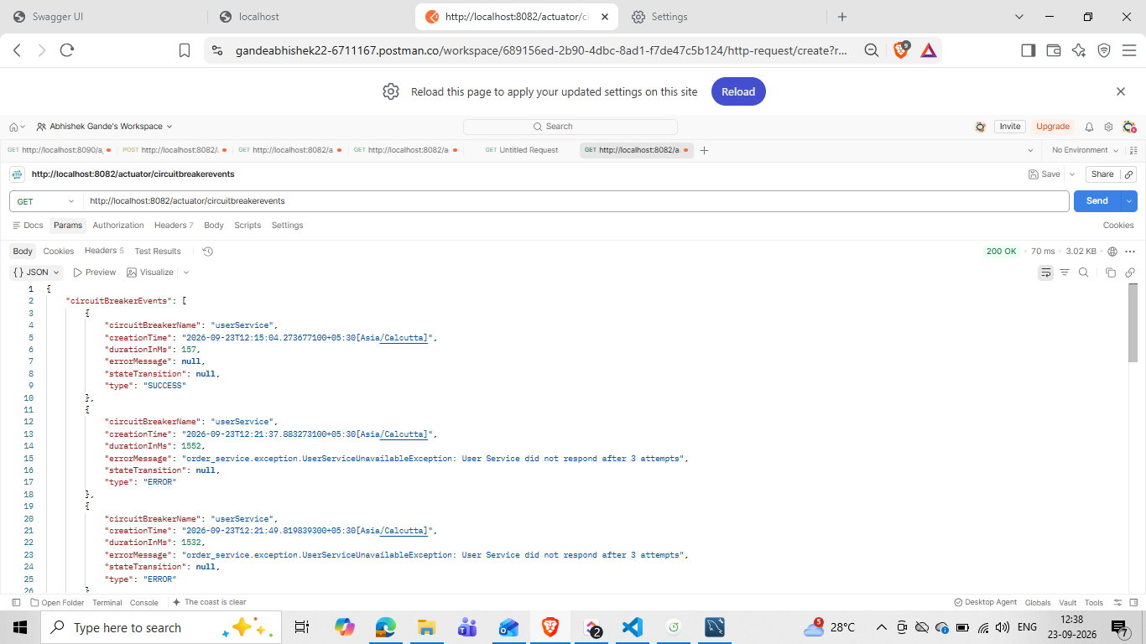
Figure 6 — Circuit Breaker event evidence: GET /actuator/circuitbreakerevents showed recorded User Service failures and retry/failure activity.
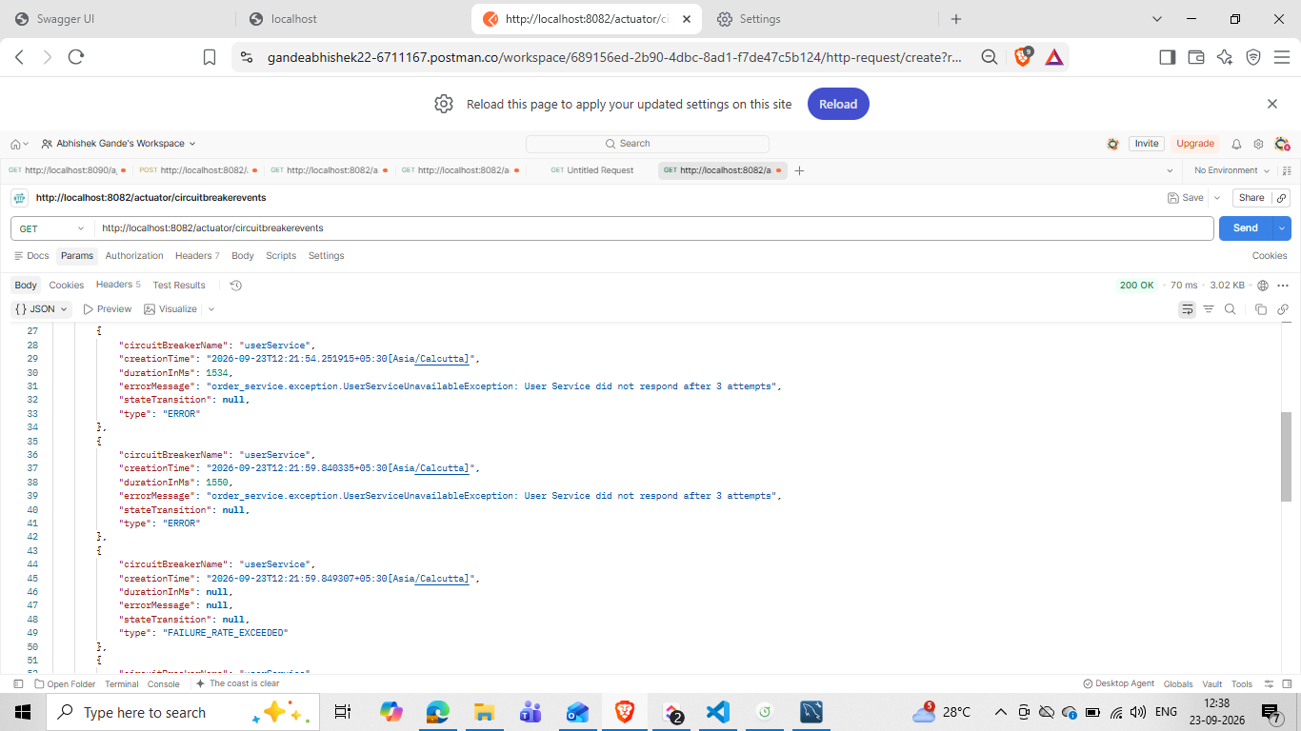
Figure 7 — Circuit Breaker threshold evidence: the event stream recorded FAILURE_RATE_EXCEEDED during repeated downstream failures.
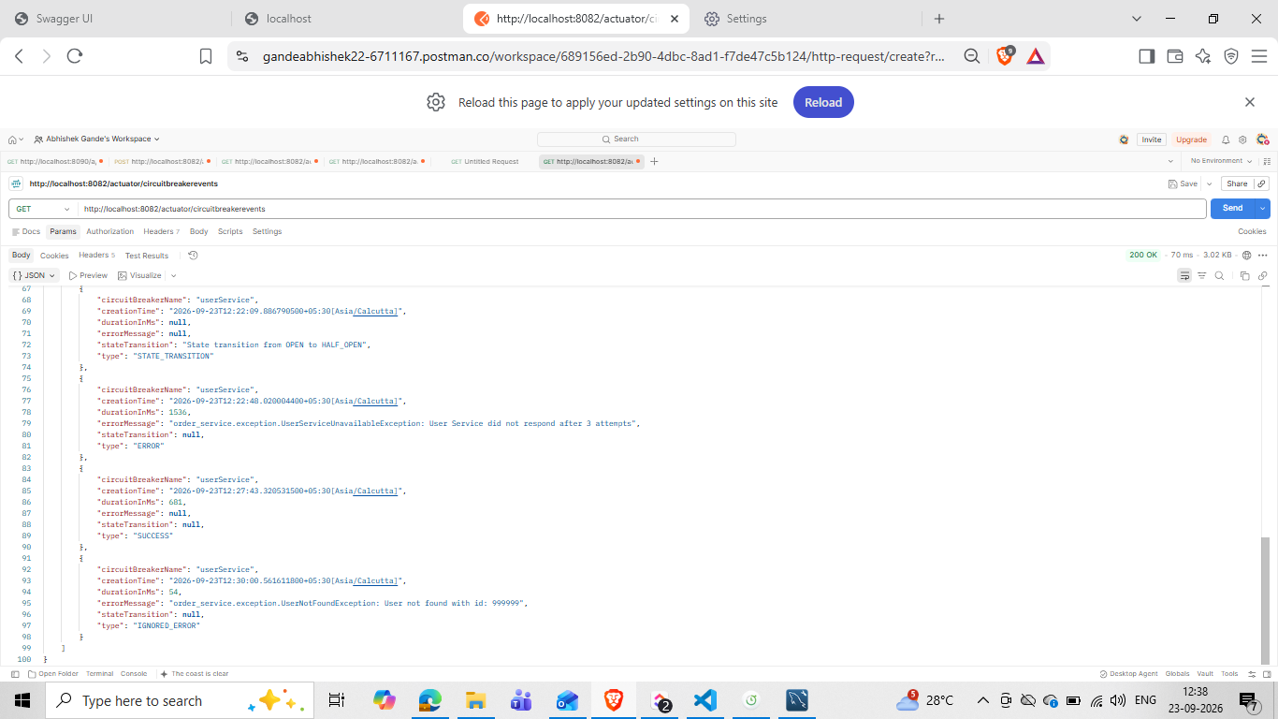
Figure 8 — Recovery and classification evidence: the event stream recorded OPEN → HALF_OPEN, a subsequent SUCCESS, and UserNotFoundException as IGNORED_ERROR.
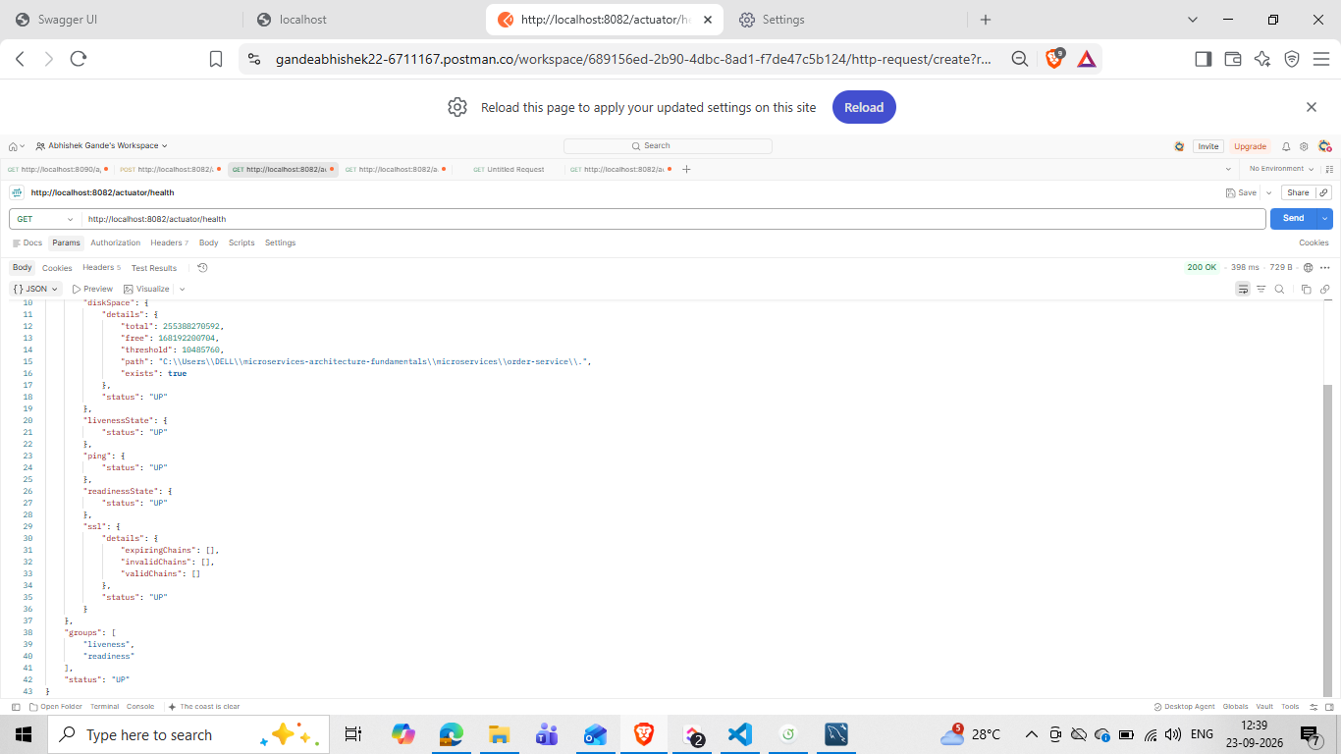
Figure 9 — Final Actuator health verification: GET /actuator/health returned HTTP 200 OK with overall application health UP.

11. Evidence Interpretation
- The health endpoint returned HTTP 200 OK and reported the application health indicators as UP, confirming the Order Service was operational during Actuator verification.
- The userService Circuit Breaker Actuator endpoint exposed the configured circuit instance and showed runtime state information, including a captured HALF_OPEN state.
- Circuit Breaker events recorded repeated User Service failures and a FAILURE_RATE_EXCEEDED event.
- The event stream explicitly recorded the state transition from OPEN to HALF_OPEN after the configured open-state waiting period.
- A later successful event corresponds to the recovered downstream call after User Service was restarted.
- The missing-user test produced UserNotFoundException and the Actuator event stream classified it as IGNORED_ERROR, demonstrating that the business-level 404 was excluded from Circuit Breaker failure counting.
Postman healthy-path evidence shows that when User Service is available, Order Service completes the synchronous user lookup and returns HTTP 201 Created for the order.
The User Service outage evidence shows the retry policy executing before final failure, followed by the Circuit Breaker/fallback path returning a controlled HTTP 503 response.
The missing-user evidence shows HTTP 404 User Not Found for userId 999999. The Actuator event stream separately records UserNotFoundException as IGNORED_ERROR, preserving the distinction between a business-level missing user and a dependency-availability failure.

12. Logging and Operational Visibility
- Request start is logged for the User Service call.
- Retry failures and retry delays are logged without secrets or credentials.
- Final downstream failure is logged after the configured maximum attempts.
- Circuit Breaker fallback activation is logged with the user ID and exception type.
- CallNotPermittedException appears when the circuit is OPEN and rejects a call.
- Actuator circuit-breaker and circuit-breaker-event endpoints provide runtime inspection for development validation.
No passwords, database credentials or authentication tokens are intentionally included in the logged retry/failure messages shown by this implementation.

13. Failure-Handling Flow
Order request
|
v
User Service call
|
+-- success ------------------------------> continue order creation
|
+-- 404 UserNotFoundException ------------> 404 (ignored by CB)
|
+-- timeout / connection / 5xx
|
v
retry
|
+-- success ---------------------> continue
|
+-- final failure --------------> UserServiceUnavailableException
|
v
Circuit Breaker
records failure
|
threshold reached
|
v
OPEN
|
fallback / 503

14. Requirement-to-Implementation Alignment
JIRA requirement | Implementation / evidence | Status
Study Circuit Breaker states | CLOSED, OPEN and HALF_OPEN documented and exercised. | Completed
Understand the flow | Failure threshold → OPEN → wait → HALF_OPEN → recovery path tested. | Completed
Add Circuit Breaker dependency | Resilience4j configured in Order Service. | Completed
Protect User Service call | @CircuitBreaker(name = "userService") applied to UserServiceClient.getUserById. | Completed
Configure thresholds | 50% threshold, minimum 5 calls, window 10, 10s open wait, 3 half-open calls. | Completed
Create fallback | getUserFallback translates dependency failures to controlled service-unavailable handling. | Completed
Test healthy service | 201 Created order verified. | Completed
Stop User Service and generate failures | Retries and final failures observed while User Service was stopped. | Completed
Restart User Service | User Service restarted and successful order creation verified. | Completed
Document state transitions | Actuator event evidence captured, including OPEN → HALF_OPEN and failure-rate exceeded. | Completed
Logging | Request, retry, final failure and fallback logging implemented. | Completed
Runtime observability | Actuator health, circuitbreakers and circuitbreakerevents verified. | Completed

15. Production-Readiness Considerations
- Circuit Breaker thresholds should be tuned using real service behavior, traffic patterns and SLOs rather than treated as universal values.
- The 2-second timeout and current retry/backoff values are development-oriented learning values and should be validated for production latency requirements.
- Retry and Circuit Breaker policies should be externalized and environment-specific.
- Fallback responses should not silently fabricate business data. The current fallback deliberately reports User Service unavailability instead of creating an artificial user.
- Actuator endpoints should be secured and selectively exposed in production. The development configuration intentionally exposes them for verification.
- The User Service base URL is externalized into configuration rather than hardcoded in Java.
- Observability should eventually include centralized metrics/log aggregation and alerting in a deployed environment.
- Circuit Breaker configuration should be version-controlled and reviewed together with the dependency's operational characteristics.

16. Scope Boundary — Task 03 vs Future Resilience Work
Task 03 focuses on Circuit Breaker state management and fallback around the existing synchronous REST dependency. It does not introduce a message broker, asynchronous event-driven fallback, distributed transaction orchestration, or a separate cached user-data fallback. Those are separate architectural concerns and should not be conflated with the Circuit Breaker pattern demonstrated here.

17. Final Deliverables Checklist
- Circuit Breaker implementation — Completed
- Resilience4j configuration — Completed
- Fallback method — Completed
- Failure simulation — Completed
- Retry + Circuit Breaker interaction — Verified
- Controlled 503 response — Verified
- Circuit OPEN behavior — Verified through logs and Actuator events
- OPEN → HALF_OPEN evidence — Captured
- Recovery path — Verified with successful order creation
- 404 non-retryable business error — Verified and recorded as IGNORED_ERROR
- Actuator health verification — Completed
- Circuit Breaker metrics/state verification — Completed
- Circuit Breaker event verification — Completed
- Runtime evidence screenshots — Included (Postman + Actuator, 9 figures)
- Technical documentation — Completed and evidence-locked

17.1 Final Evidence Lock
The implementation, configuration values, service ports, database profile, retry behavior, Circuit Breaker state transitions, fallback behavior, Actuator verification and the supplied Postman evidence have been cross-checked against the current Task 03 test session. This document intentionally records the evidence as observed and does not infer results beyond the captured outputs. No additional runtime screenshot is required for the Task 03 deliverables represented here.

18. Conclusion
JIRA Task 03 demonstrates the addition of a Circuit Breaker around the Order Service dependency on User Service. The implementation combines the previously established timeout/retry handling with a bounded Circuit Breaker policy and a controlled fallback response. The supplied runtime evidence shows normal operation, downstream failure, failure-rate threshold handling, OPEN-state rejection, recovery testing through HALF_OPEN, successful recovery, and correct treatment of a missing-user 404 as an ignored business error.
The resulting design reduces repeated traffic to an unavailable dependency and gives the Order Service a predictable failure response while preserving the distinction between infrastructure/service failures and normal business-level resource-not-found responses.

Appendix A — Key Development Configuration
spring:
application:
name: order-service
profiles:
active: dev
resilience:
user-service:
base-url: http://localhost:8090
connect-timeout-ms: 2000
read-timeout-ms: 2000
max-retry-attempts: 3
initial-backoff-ms: 500
server:
port: 8082
spring.datasource:
url: jdbc:mysql://localhost:3306/order_service_db

Appendix B — Verification Endpoints
Endpoint | Purpose | Observed
GET http://localhost:8082/actuator/health | Overall Order Service health | 200 OK / UP
GET http://localhost:8082/actuator/circuitbreakers | Current Circuit Breaker instances and metrics | 200 OK / userService exposed
GET http://localhost:8082/actuator/circuitbreakerevents | Circuit Breaker runtime event history | 200 OK / failure and state-transition evidence
POST http://localhost:8082/api/v1/orders | Healthy order creation | 201 Created
POST http://localhost:8082/api/v1/orders with userId 999999 | Missing-user business error | 404 Not Found

END OF JIRA TASK 03 DOCUMENTATION

